# PowerShell Lab 4 – KEY

## Exercise with Where-Object

$a = Import-Csv .\users.csv  
$a | Get-Member  
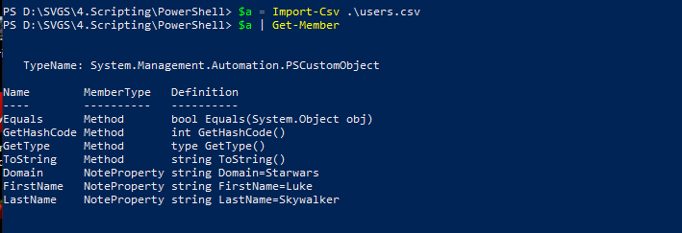

$a = Import-Csv .\users.csv  
$a | Where-Object {$_.Domain -eq "Hogwarts"}

Or  
Import-Csv .\users.csv | ? Domain -eq “Hogwarts”

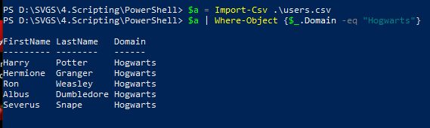

## Exercise with ForEach-Object

$a = Import-Csv .\users.csv  
$a | ForEach-Object {$_.FirstName + "." + $_.LastName + "@" + $_.Domain + ".edu"}

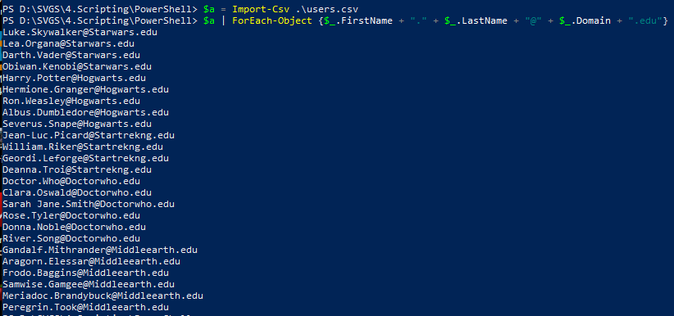

## Exercise with Calculated Properties

Import-Csv .\users.csv | Select-Object -Property @{Name='Email'; Expression = {$_.FirstName + "." + $_.LastName + "@" + $_.Domain + ".edu"}}

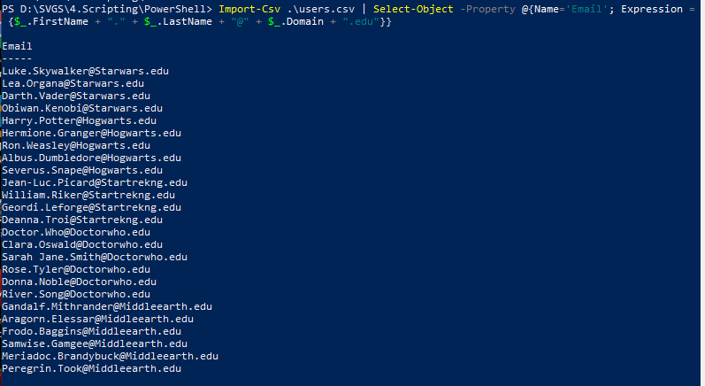

Import-Csv .\users.csv | Select-Object -Property LastName, @{Name='Email'; Expression = {$_.FirstName + "." + $_.LastName + "@" + $_.Domain + ".edu"}}

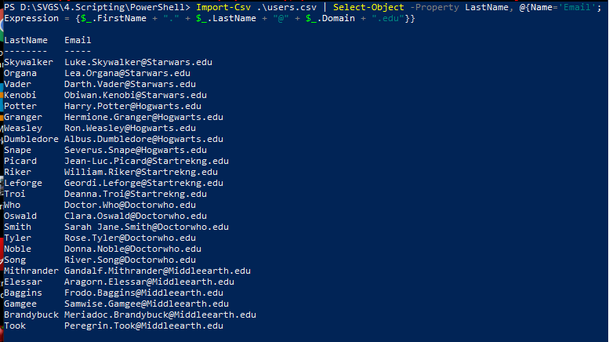

Import-Csv .\users.csv | Select-Object -Property LastName, @{Name='Email'; Expression = {$_.FirstName + "." + $_.LastName + "@" + $_.Domain + ".edu"}} | Get-Member

